**1.HTML Basics - Formatted tags**

Anastasia is undertaking an online course on HTML concepts offered by Alison Techno Solutions. She has successfully completed the learnings and exercises on the basic concepts and so her tutor gave her a task on the same. The task was to create a HTML webpage which should explain the functionality of a basic text editor. Though Anastasia knew the concepts well, she requested your help to finish the task assigned. In a basic text editor, formatting plays a vital role, so its important to incorporate various html tags like bold, italics, underlined etc., Let us help Anastasia by writing a html code that explains formatted tags in html.

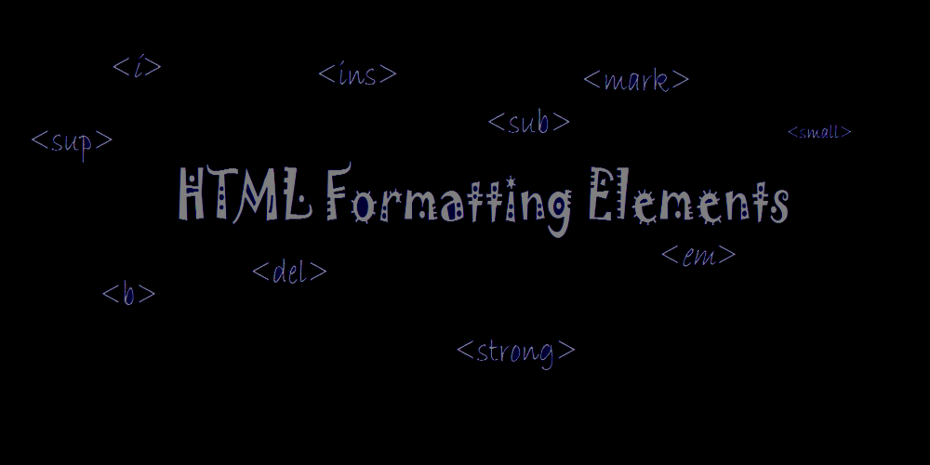

 Hints :

Tag <b> The HTML <b> tag is used for specifying bold text.

Tag <i> The HTML <i> tag is used for displaying the content in italic.

Tag <mark> The HTML <mark> tag is used to highlight text in a paragraph.

Tag <u> The HTML <u> tag is used to highlight the content by underline.

Tag <del> The HTML <del> tag is used for markup of deleted text. Browsers will normally strike a line through deleted text.

Tag <sup> The HTML <sup> tag defines superscript text. Superscript text appears half a character above the normal line, and is sometimes

rendered in a smaller font.

Tag <sub> The <sub> tag defines subscript text. Subscript text appears half a character below the normal line, and is sometimes rendered in a smaller font.

Tag <ins> The HTML <ins> tag defines a text that has been inserted into a document. Browsers will normally strike a line through deleted text and underline inserted text.

Tag <small> The HTML <small> tag makes text one font size smaller in the HTML document.

Content :  
Bold  
Seeing good in every situation is the best attitude one can develop.  
Italic  
Seeing good in every situation is the best attitude one can develop.  
Markable Text  
Do not forget to buy milk today.  
Underline  
Mahatma Gandhiji is revered in India as the Father of the Nation.  
Deleted Text  
Today's Special: Salmon SOLD OUT  
Superscript  
10 to the power of 9 is represented as 10<sup>9  
Subscript  
Members of the 16th Lok Sabha were elected during the 2014 Indian general election.  
Inserted Text  
My favorite color is blue red!  
Smaller Font  
Copyright @ 2012. All rights reserved.

Constraints :  
Tag 'b' must be present minimum 1 time in the html page.  
Tag 'i' must be present minimum 1 time in the html page.  
Tag 'mark' must be present minimum 1 time in the html page.  
Tag 'u' must be present minimum 1 time in the html page.  
Tag 'del' must be present minimum 1 time in the html page.  
Tag 'sup' must be present minimum 1 time in the html page.  
Tag 'sub' must be present minimum 1 time in the html page.  
Tag 'ins' must be present minimum 1 time in the html page.  
Tag 'small' must be present minimum 1 time in the html page.

Note :  
Content of the page should be present as shown in the screenshot.  
Kindly refer the content which is given as a part of description

Sample Screenshot 1 :  
  
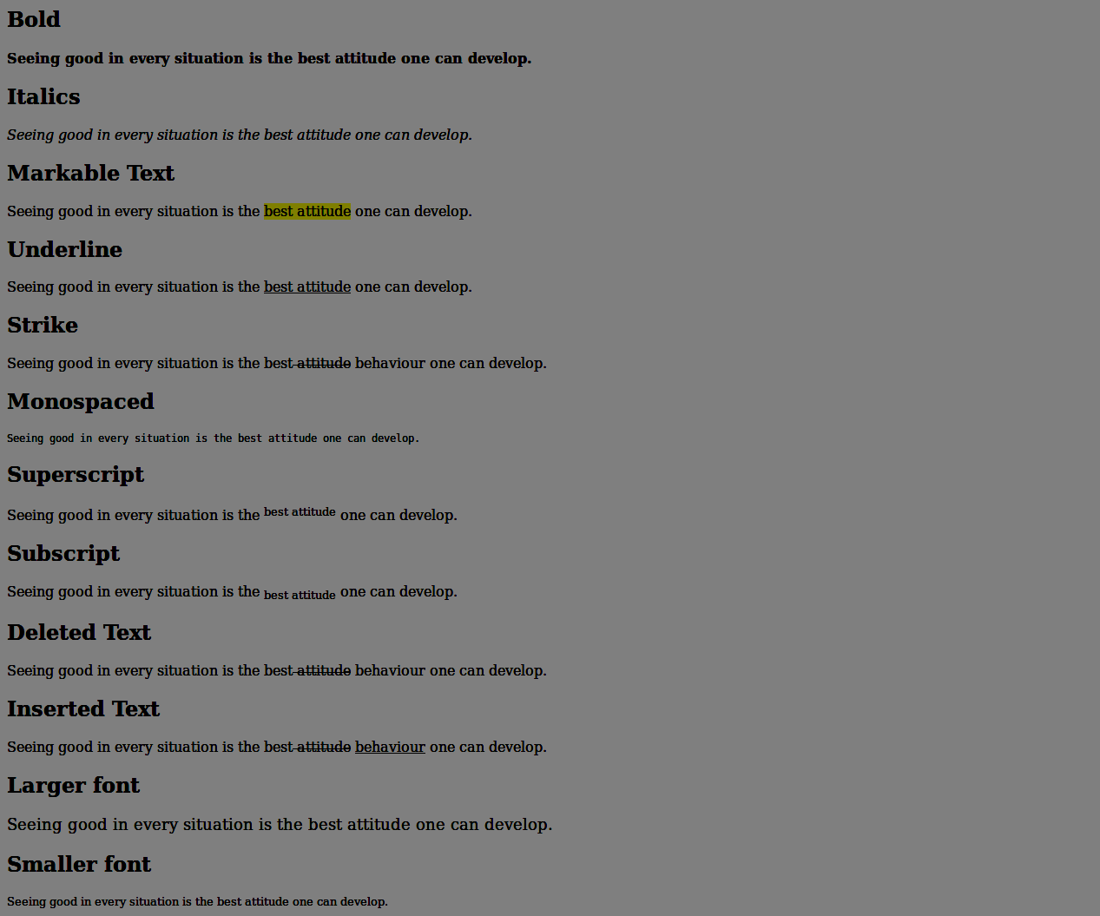

**2. CSS - text transform**

In the process of creating the official website for the famous event managing brand "Pink Frag Event Organizer", Haveena has collected the textual content for the site. Since the content was too large, it consumed lot of time for her to type the content in desired text-styles like lowercase, uppercase, capitalize, etc., In order to save time she decided to re-model her text into the HTML code, but was unable to convert a part of text to Uppercase or to be capitalized.    
  
Then, the usage of text-transform property struck out in her mind. The text-transform property controls the capitalization of text. As she is busy in collecting contents, she has assigned you the task of converting the rough content into the webpage using text-transform property in CSS.

**Hints :**

**text-transform property :**

The text-transform property in CSS controls text case and capitalization.

lowercase - makes all of the letters in the selected text lowercase.

uppercase - makes all of the letters in the selected text uppercase.

capitalize - capitalizes the first letter of each word in the selected text.

none - leaves the text's case and capitalization exactly as it was entered.

inherit - gives the text the case and capitalization of its parent.

text-transform property

Syntax :

text-transform: none|capitalize|uppercase|lowercase|initial|inherit;

**Content :**  
h1 - Pink Frag Event Organizer  
div class="wedding"  
h3 - Wedding Event  
p - Our passionate team of wedding experts are meticulous in ensuring that every aspect of the day is seamlessly stylish, from our delectable menus to glorious flowers, venue finding and dressing, production and entertainment.  
div class="conference"  
h3 - Conferences  
p - Our conferences are designed to meet the ever-changing needs of the customer, with the goal of bringing industry professionals together to share their expertise, exchange ideas and facilitate business.  
div class="birthdayParty"  
h3 - Birthday Party  
p - Planning a birthday party? Whether a wild party with friends or a crazy party for the kids,Most importantly, Purple7 helps you gather that ever important catering services will be arranged as per your requirements and budget.Engage your guests in variety of events.Host the party with a lively anchor.  
div class="liveShows"  
h3 - Live Shows  
p - If you are looking for entertainment any time of the day or night, then you are at the right place. We bring you the list of all the hot and happening entertaining events/activities going on or lined up in Coimbatore. You just need to tell us your mood and taste in entertainment, rest we ensure you get the best time of your life.  
div class="photography"  
h3 - Photography  
p - We capture your best moments in life and make it an everlasting treasure to preserve. We are well experienced in events coverage, wedding photography, candid photography, modelling photography and industrial photography. Make use of our photography services for a lasting impression.  
  
**Constraints :**  
The following text-transform properties must be applied for the <div> elements respectively

Apply text-transform - none for div with class 'wedding'  
Apply text-transform - uppercase for div with class 'conference'  
Apply text-transform - lowercase for div with class 'birthdayParty'  
Apply text-transform - capitalize for div with class 'liveShows'  
Apply text-transform - inherit for div with class 'photography'

The 'div' id should be same as given in the screenshot.  
The header and the content should be same as the given content.  
  
**Note :**  
Content of the page should be present as shown in the screenshot.  
Kindly refer the content which is given as a part of description  
  
**Sample Screenshot 1 :  
  
